**Report**

**on**

**Constitution Day**

**25th November, 2024 – 26th November, 2024**

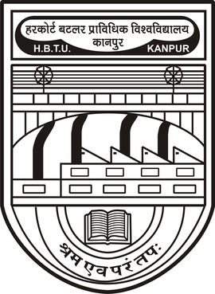

**Organized by: Hobby Sub-Council, U.S.A.C.**

**Harcourt Butler Technical University**

Nawabganj, Kanpur – 208002, U.P., India

The Hobby Sub-Council, under the University Student Activity Council (U.S.A.C.) of Harcourt Butler Technical University (HBTU), Kanpur, organized a grand celebration on the occasion of Constitution Day. The two-day event, held on 25th November and 26th November 2024, was a blend of educational activities and competitions aimed at raising awareness about the significance of the Indian Constitution and inspiring students to honor its values in their lives.

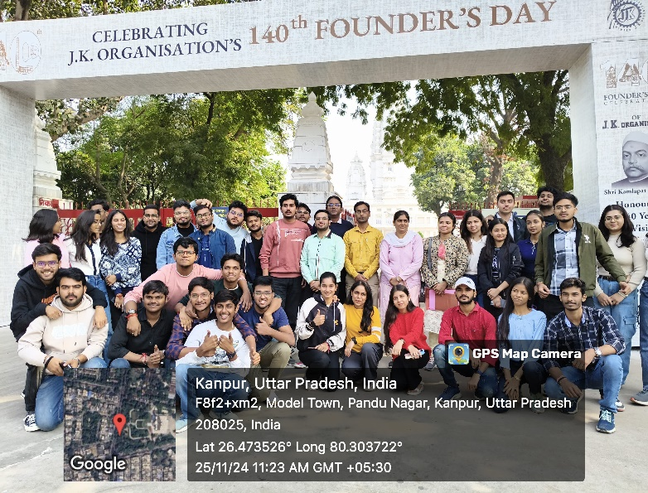 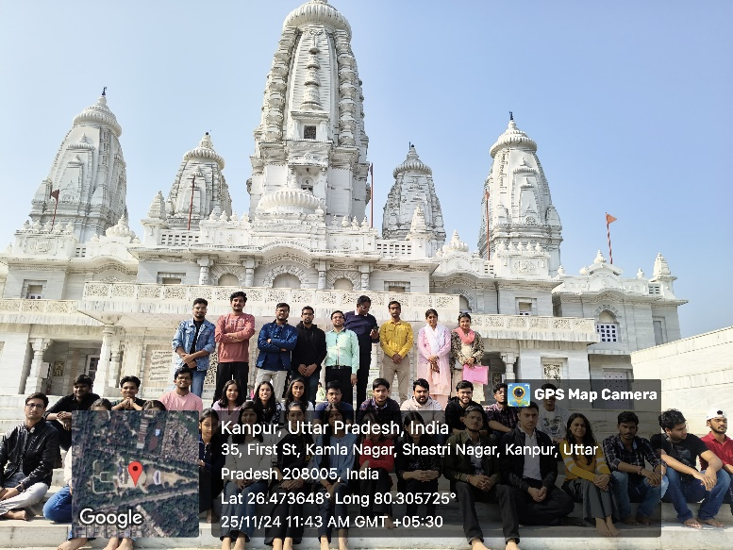

On 25th November 2024, an educational visit was organized for approximately 37 students from the 1st year and 2nd years students of all departments. The visit was planned to historical landmarks in Kanpur, including JK Temple and Nana Rao Park, Phool Bagh. At JK Temple, students marveled at the intricate architecture and its representation of Indian culture. Students also learned about the contribution of J.K. Singhania and that he was an active member of the Constituent Assembly of India, contributing to the debates and discussions surrounding the drafting of the Indian Constitution. His involvement focused on issues related to social justice and the protection of minority rights, reflecting his commitment to ensuring an inclusive and equitable framework for the newly independent nation.

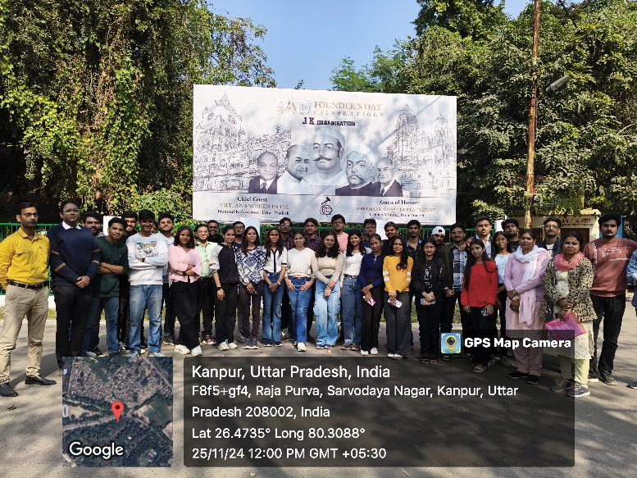 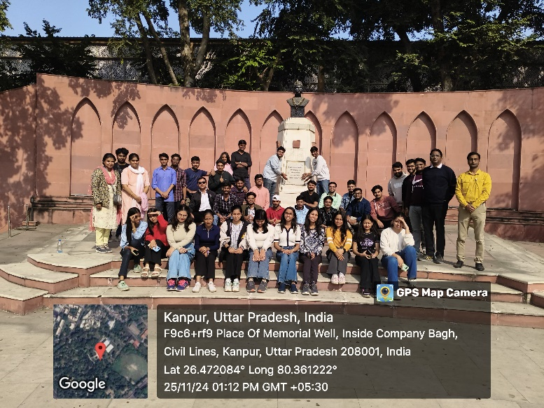

The visit to Nana Rao Park, Phool Bagh proved particularly impactful as students learned about the contributions of iconic freedom fighters and key figures who played pivotal roles in the Constituent Assembly. The statues of personalities like Dr. B.R. Ambedkar provided a visual connection to their contributions in drafting the Indian Constitution. Shaheed Smarak and the sites at Nana Rao Park are memorials dedicated to the sacrifices made during India's struggle for independence. While not directly involved in the Constituent Assembly, these sites symbolize the spirit of freedom and the values of sacrifice, which inspired the framers of the Constitution in their work to create a just and democratic nation. The trip not only deepened the students’ understanding of history but also highlighted the sacrifices and efforts that laid the foundation of India’s democratic framework.

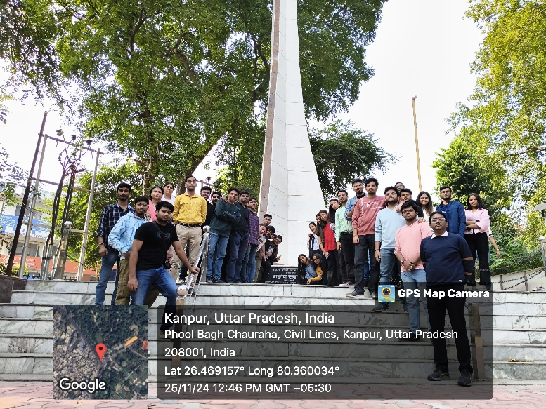 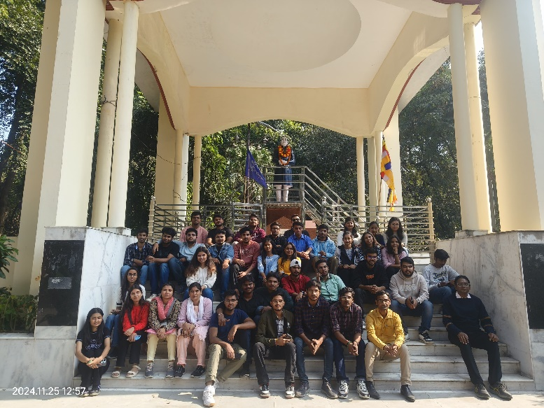

The main event was held on 26th November 2024 at the New Auditorium of HBTU. The day commenced with three competitions: Speech, Rangoli Making, and Painting. In each competition approximately 12 to 15 students participated from 1st year and 2nd year of all branches and degrees. These competitions, designed around the theme of the Indian Constitution, saw enthusiastic participation from students across departments. The Speech Competition revolved around topics related to the Constitution, emphasizing its values and principles, with participants delivering speeches in Hindi and English. The Rangoli Making Competition showcased creative interpretations of the Constitution using natural and eco-friendly materials, while the Painting Competition brought the Constitution’s significance to life through vibrant artworks. Each competition was judged by an esteemed inter-departmental faculty panel, ensuring fairness and transparency. The winners of the competitions were later felicitated during the closing ceremony.

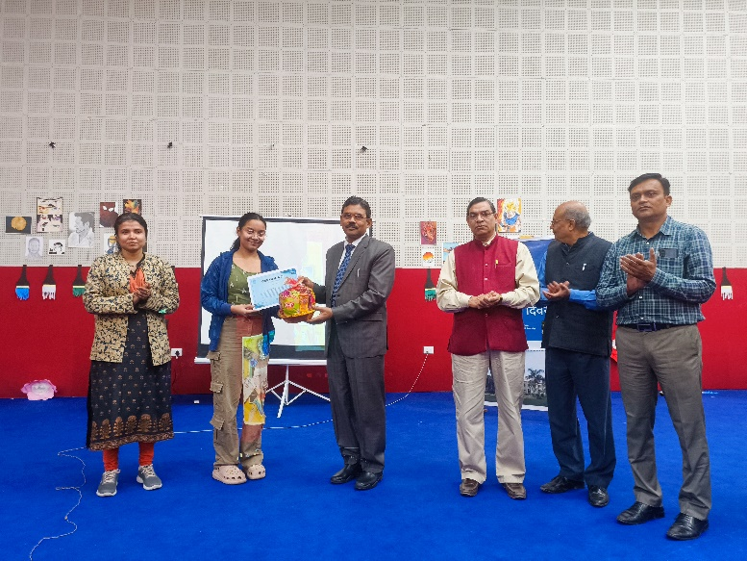 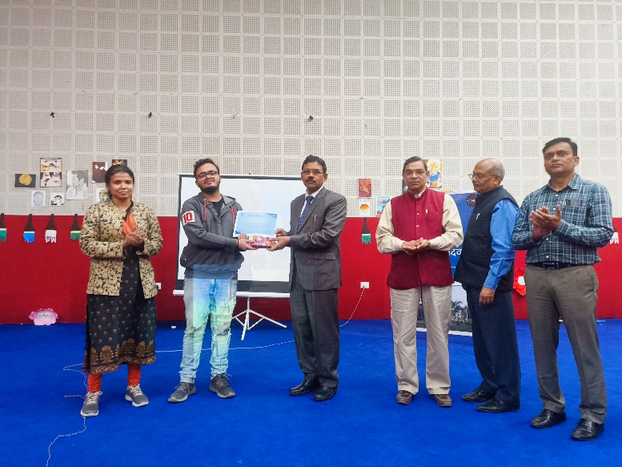

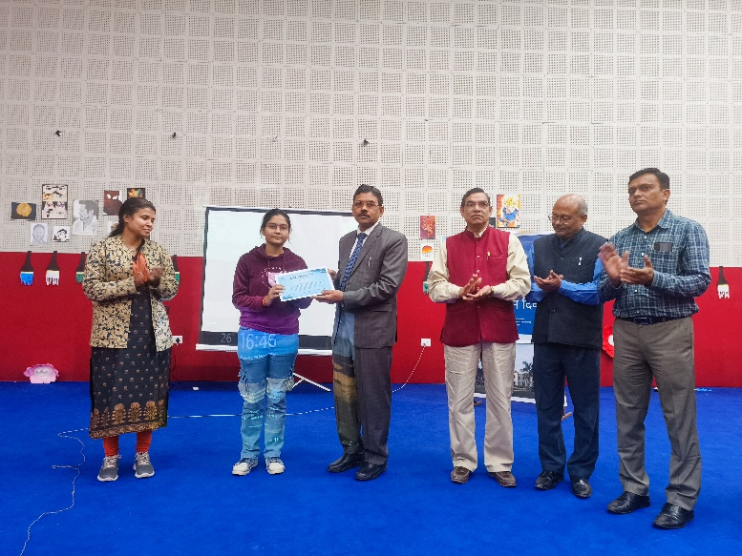 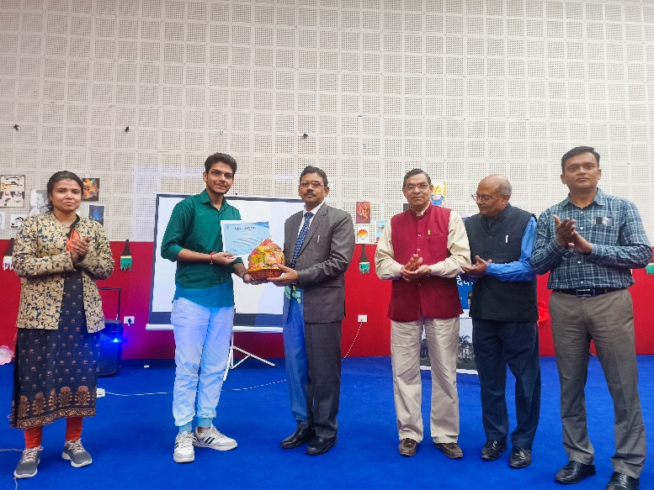

The event was attended by several guests, including the Hon’ble Vice-Chancellor of HBTU, the Dean, Student Welfare, the Deputy Secretary of U.S.A.C., and faculty members from various departments. The dignitaries addressed the audience, underscoring the importance of the Constitution in shaping the nation’s governance and democratic ethos. A significant part of the event was a detailed explanation of the Indian Constitution, focusing on key aspects such as the Directive Principles of State Policy, Fundamental Rights, and Fundamental Duties. The discussions also touched upon landmark judgments that have shaped constitutional law in India, making the session both informative and thought-provoking for the attendees.

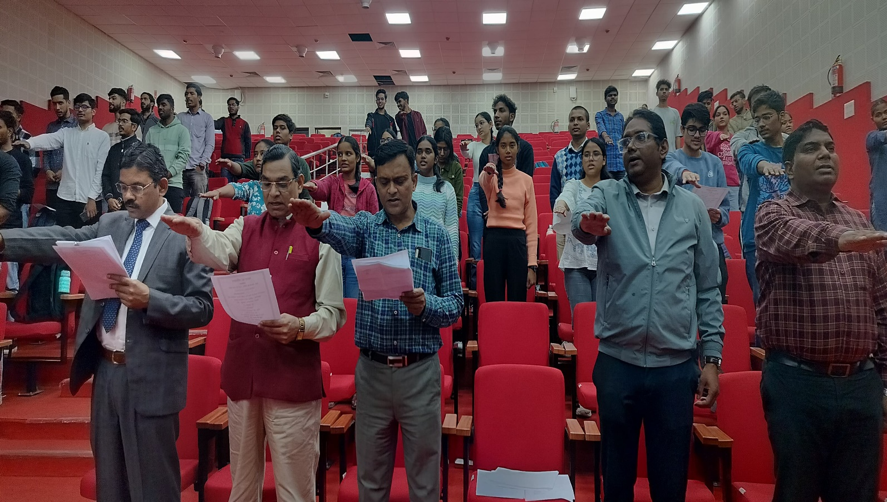

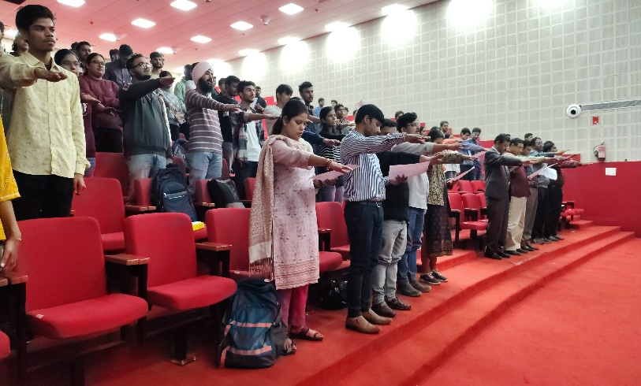 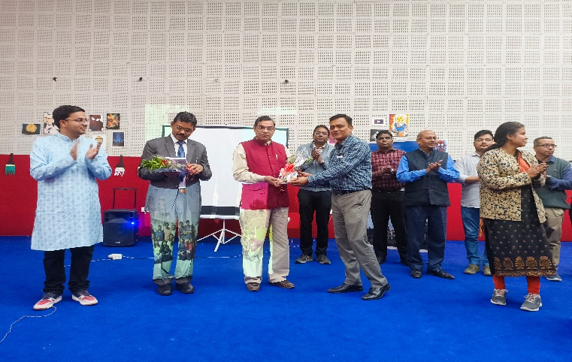

A solemn oath-taking ceremony followed, where students and faculty pledged to uphold the values of the Constitution, committing themselves to the ideals of justice, equality, and fraternity. This symbolic act reinforced the importance of actively embracing the principles enshrined in the Constitution. To further commemorate the day, copies of the Indian Constitution were presented as mementos to the Hon’ble Vice-Chancellor, the Dean of Student Welfare, and other key guests. Additional copies were donated to the university library, ensuring that students have access to this essential document for their academic and personal growth.

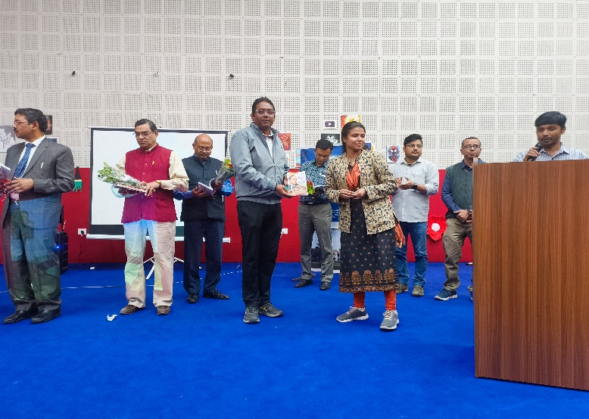 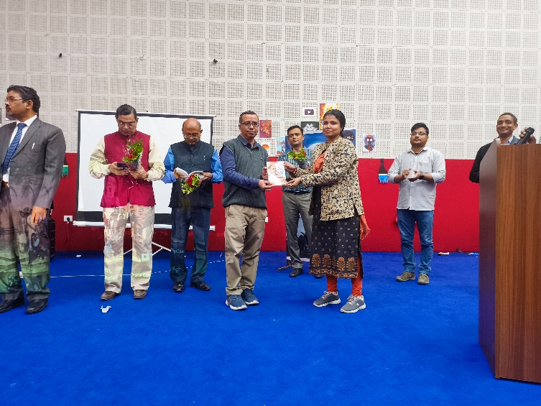

Continuing the celebration of Constitution Day, the day was packed with a variety of engaging activities that encouraged students to explore and express their understanding of the Constitution. The painting competition was a vibrant display of creativity, with each participant bringing their unique vision to life. The judges were delighted by the array of beautiful paintings, each revolving around the theme of the Constitution and its significance. It was a vivid celebration of artistic expression, capturing the essence of our nation's guiding principles through colour and brushstrokes.

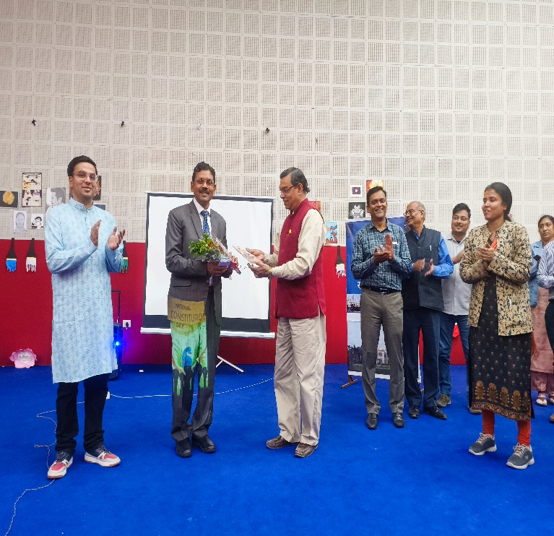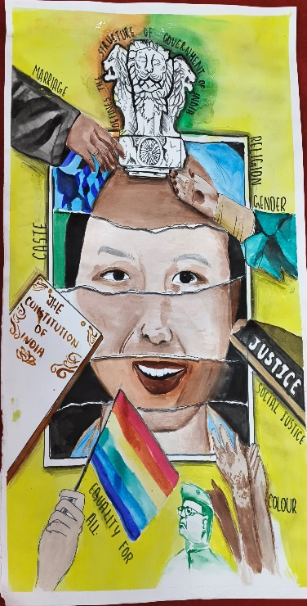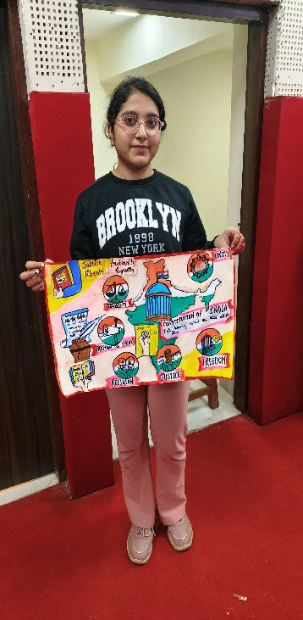

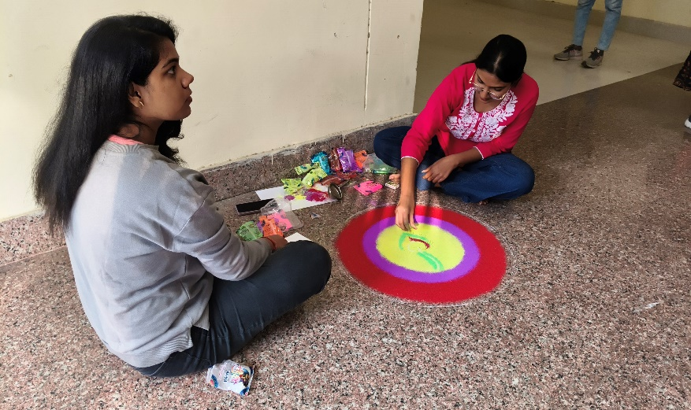 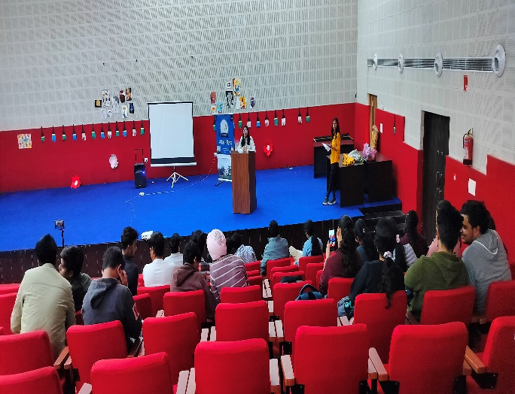

Following the painting competition, the speech competition brought the audience to the edge of their seats with a series of fantastic speeches. Students eloquently shared their insights and reflections on the Constitution and its foundational principles. Each speech was a testament to the students' deep understanding and appreciation of the Constitution, highlighting its importance in shaping our society. The passion and clarity with which the participants spoke left a lasting impression on everyone present.

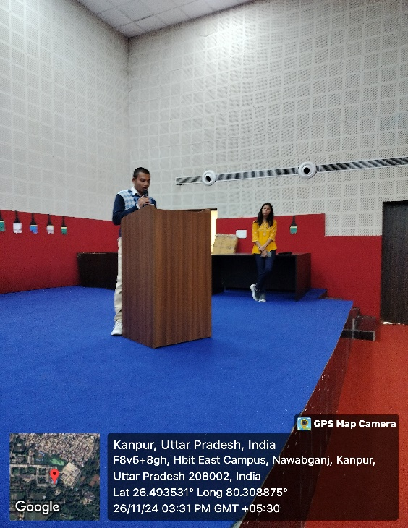 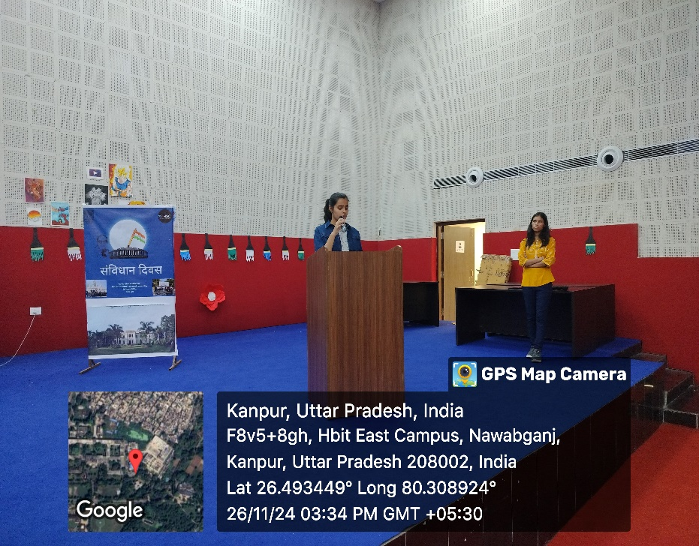

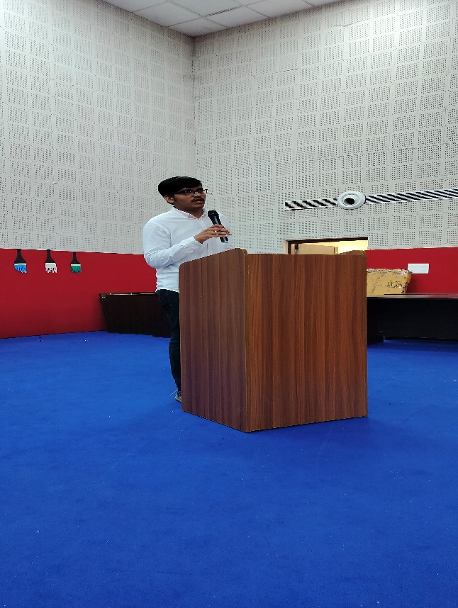 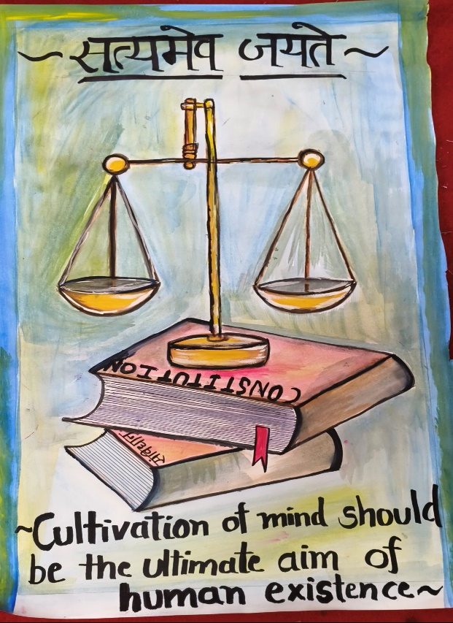

The event concluded with a captivating rangoli-making competition, where students showcased their artistic prowess through intricate designs and vibrant colors. The participants poured their hearts into creating beautiful rangolis that not only adhered to the theme but also displayed their exceptional skill and creativity. The judges had a tough time deciding the winners, as each rangoli was a masterpiece in its own right, contributing to a mesmerizing visual celebration of Constitution Day.

These activities not only celebrated Constitution Day but also fostered a sense of unity and pride among the students, reinforcing the values embedded in our Constitution through creative and intellectual engagement.

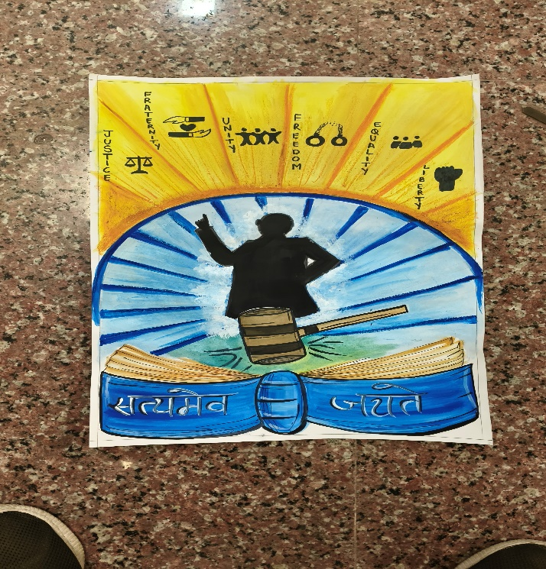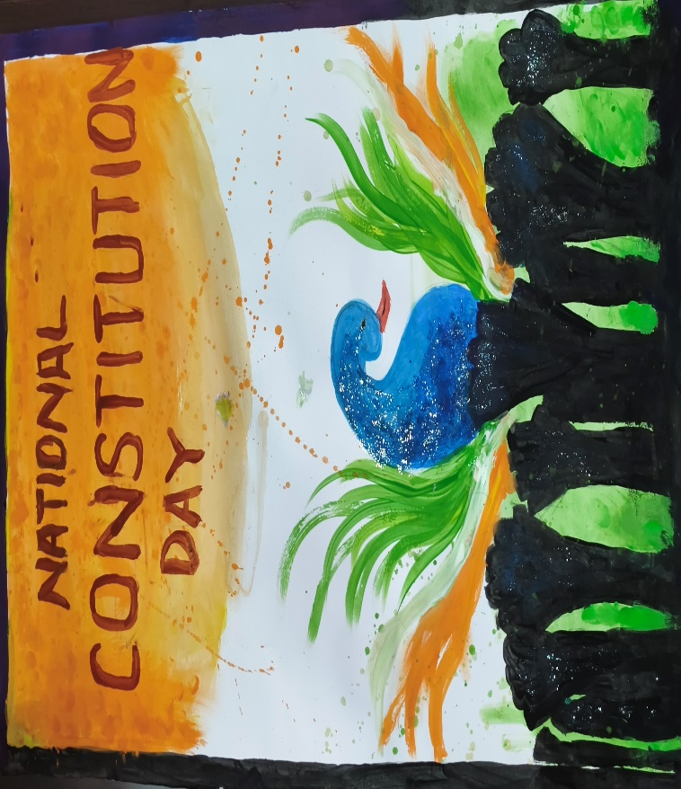 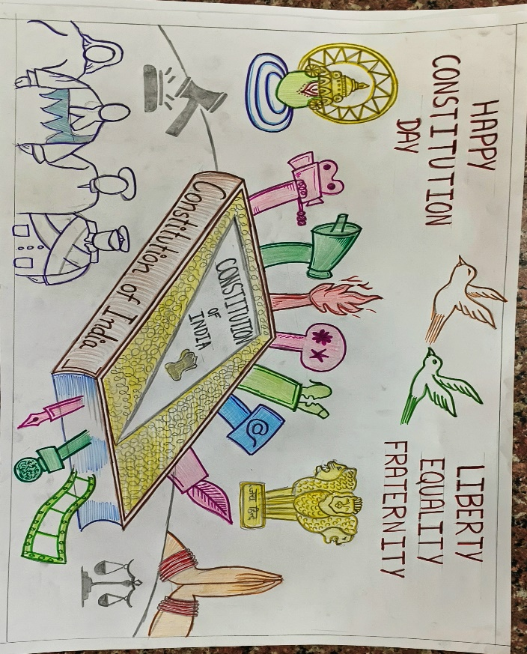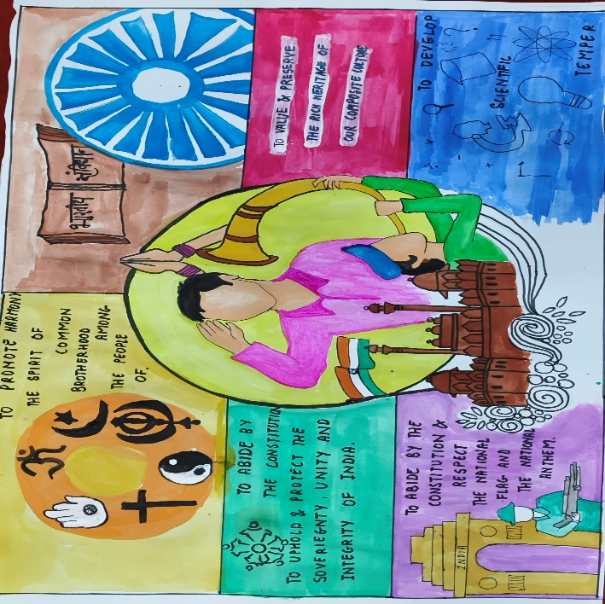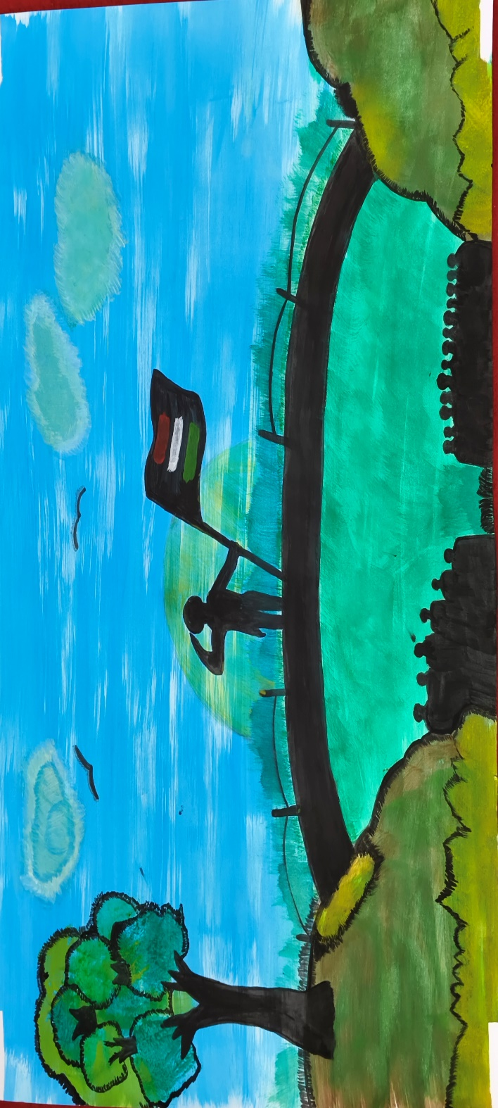

The day concluded with a felicitation ceremony where winners of the competitions were awarded certificates and accolades for their exceptional performances. Among the winners were Vanya for Painting, Titisa Uttam for Rangoli Making, and Kishlay Tiwari for Speech Competition, all of whom displayed remarkable talent and dedication to the theme.

**List of Winners in Speech Competition**

|  |  |  |  |  |
| --- | --- | --- | --- | --- |
| **Position** | **Name** | **Branch** | **Year** | **Contact Number** |
| 1st | Kishlay Tiwari | Civil Engineering | 2nd B.Tech. | 7355305819 |
| 2nd | Shipra Dwivedi | Bio – Chemical Engineering | 1st B.Tech. | 92363 53159 |
| 3rd | Shivashish Mehrotra | Computer Science and Engineering | 1st B.Tech. | 7985455684 |

**List of Winners in Rangoli Competition**

|  |  |  |  |  |
| --- | --- | --- | --- | --- |
| **Position** | **Name** | **Branch** | **Year** | **Contact Number** |
| 1st | Titisa Uttam | Civil Engineering | 2nd B.Tech. | 7355305819 |
| 2nd | Shrasti Sachan | B. B. A. | 2nd B.Tech. | 9696041783 |
| 3rd | Sanjana | Electronic Engineering | 2nd B.Tech. | 6386524896 |

**List of Winners in Painting Competition**

|  |  |  |  |  |
| --- | --- | --- | --- | --- |
| **Position** | **Name** | **Branch** | **Year** | **Contact Number** |
| 1st | Vanya Singh | Information Technology | 1st B.Tech. | 9412802911 |
| 2nd | Anshika Bhatnagar | Information Technology | 1st B.Tech. | 8471036401 |
| 3rd | Kanishka Gupta | Information Technology | 1st B.Tech. | 6386629223 |

**Participants in Painting Competition**

|  |  |  |  |  |
| --- | --- | --- | --- | --- |
| **Name** | **Roll Number** | **Branch** | **Year** | **Contact Number** |
| Shreya Yadav | 240230164 | MBA | 1st MBA | 8400421387 |
| Suraj Mishra | 240230181 | MBA | 1st MBA | 7017543748 |
| Suryansh Sahu | 240103070 | Chemical Engineering | 1st B.Tech. | 6387611981 |
| Apurva | 240137004 | BSMS | 1st BSMS | 9536718412 |
| Rishabh Singh | 240137026 | BSMS | 1st BSMS | 7409868805 |
| Samriddhi jain | 231036046 | BBA | 2nd BBA | 8318727714 |
| Vanya Singh | 240108082 | Information Technology | 1st B.Tech. | 7060555050 |
| Abhisar Singh | 240105004 | Electrical Engineering | 1st B.Tech. | 8755258896 |
| Tanya Prajapati | 240102078 | Civil Engineering | 1st B.Tech. | 8840010496 |

**Participants in Rangoli Competition**

|  |  |  |  |  |
| --- | --- | --- | --- | --- |
| **Name** | **Roll Number** | **Branch** | **Year** | **Contact Number** |
| Sanjana | 230106048 | Electronic Engineering | 2nd B.Tech. | 6386524896 |
| Riddhima Pandey | 240111045 | Oil Technology | 1st B.Tech. | 9696488713 |
| Titisa Uttam | 230102070 | Civil Engineering | 2nd B.Tech. | 9302153752 |
| Shivani dubey | 240230155 | MBA | 1st MBA | 9935280741 |

**Participants in Speech Competition**

|  |  |  |  |  |
| --- | --- | --- | --- | --- |
| **Name** | **Roll Number** | **Branch** | **Year** | **Contact Number** |
| Tanmai Ratta | 240136063 | BBA | 1st BBA | 9193466611 |
| Bharat Agarwal | 240230053 | MBA | 1st MBA | 8318509743 |
| Meenakshi Yadav | 230101027 | Bio Chemical Engineering | 2nd B.Tech. | 7376498582 |
| Shreya Singh | 240108068 | Information Technology | 1st B.Tech. | 9315897479 |
| Siddhi Agarwal | 240101045 | Bio Chemical Engineering | 1st B.Tech. | 91292 94839 |
| Devansh | 230102028 | Civil Engineering | 2nd B.Tech. | 7460907134 |

**Participants in Historic Visit**

|  |  |  |  |  |
| --- | --- | --- | --- | --- |
| **Name** | **Roll Number** | **Branch** | **Year** | **Contact Number** |
| Aviral Jaiswal | 230106020 | Electronics engineering | 2nd B.Tech. | 8005334292 |
| Aarav Kumar | 240108002 | Information Technology | 1st B. Tech | 9984106127 |
| Kanishtha mishra | 240109006 | Leather technology | 1st B. Tech | 7524919731 |
| Uday Gupta | 230101055 | Biochemical Engineering | 2nd B.Tech. | 8630094917 |
| Shraddha Rajput | 230109022 | CIVIL ENGINEERING | 2nd B.Tech. | 6393400773 |
| Abhay Pal | 240139001 | Biotechnology | 1st B. Tech | 7307551765 |
| DEVANSH | 230102028 | CIVIL ENGINEERING | 2nd B. Tech | 7460907134 |
| Esha Yadav | 240110030 | Mechanical engineering | 1st B. Tech | 8953912205 |
| Pummy Rathore | 240139041 | Biotechnology | 1st B. Tech | 9455719971 |
| Piyush Singh | 240111039 | Oil technology | 1st B.Tech. | 8383993632 |
| Tuhin Ghosh | 230103070 | Chemical Engineering | 2nd B.Tech. | 9555912693 |
| Neha Chauhan | 240102043 | Civil engineering | 1st B.Tech. | 8506949906 |
| Sonia Sharma | 240108071 | Information technology | 1st B.Tech. | 9320657400 |
| Pradhumn Upadhyay | 240137021 | BS MS | 1st B. Tech | 9761880667 |
| Aditya saini | 240110008 | Mechanical engineering | 1st B.Tech. | 6396242475 |
| Meenakshi Yadav | 230101027 | Biochemical Engineering | 2nd BTech | 7376498582 |
| Anup pal | 240137003 | BS MS | 1st B.Tech. | 8982645429 |
| Prashansa Goswami | 240112038 | Plastic Technology | 1st B.Tech. | 6306422847 |
| Aayush Kumar | 240103002 | Chemical engineering | 1st B. Tech | 8791332960 |
| Pradhumn Upadhyay | 240137021 | BS MS | 1st B.Tech. | 9761880667 |
| Arpit Pandey | 240106020 | Electronics Engineering | 1st B.Tech. | 9260957680 |
| Shreya Upadhyay | 240112050 | Plastic Technology | 1st B.Tech. | 7457071907 |
| Shashwat Chowdhary | 230103053 | Chemical Engineering | 2nd B. Tech | 7024366620 |
| Suraj Mishra | 230103064 | Chemical Engineering | 2nd B. Tech | 75188 53336 |
| Prashant Diwedi | 220110080 | Mechanical Engineering | 3rd B.Tech. | 9305678269 |
| Rishabh Kushwaha | 220110052 | Mechanical Engineering | 3rd B.Tech. | 7355083996 |
| Peeyush Sharma | 220105035 | Electronic Engineering | 3rd B.Tech. | 9336399633 |
| Unnayan Srivastava | 220113052 | Chemical Engineering | 3rd B.Tech. | 9336991922 |
| Harsh Kapil | 220102028 | Civil engineering | 3rd B.Tech. | 7895621728 |
| Sannidhya Naveen Upadhyay | 220102057 | Civil engineering | 3rd B.Tech. | 7388440777 |
| Anas Aleem | 220102013 | Civil engineering | 3rd B.Tech. | 8979637774 |
| Vartika Patel | 230106066 | Electronic Engineering | 2nd B.Tech. | 63921 78042 |
| Anshuman Mishra | 230137003 | BS MS | 2nd B.Tech. | 98181 06471 |
| Lakshya Veer Singh | 240111031 | Oil Technology | 1st B.Tech. | 9236509414 |
| Devkriti Dubey | 240137003 | Biotechnology | 1st B.Tech. | 9555405892 |
| Kanishtha Mishra | 240109006 | Leather Technology | 1st B.Tech. | 75249 19731 |
| Harshit Kumar | 240108031 | Information Technology | 1st B.Tech. | 9118219068 |